esure

**Test Plan – SW Motor Q&B, All Devices Test Name: Best match prominence**

Author: Rosie Enoch

11/05/2022

|  |  |  |
| --- | --- | --- |
| Name | Version | Changes |
| Consultant name | 1 | Document created |
|  |  |  |
|  |  |  |

**Jira Ticket Number**

OT-296

**Test Background**

Evidence

User testing has highlighted that the best match tag we add to the breakdown product tiers, helps a user understand which tier best suits their demands and needs. We want to test highlighting the column further by adding some animation/styling to it.

Hypothesis

By changing the breakdown best match design by using styling and animation so it appears more obvious, we will increase clarity and therefore increase breakdown uptake% of higher tiers.

Test Goal

BK3 & BK5 uptake%

**Targeting**

|  |  |  |
| --- | --- | --- |
| **Name** | **Description** | **Example URLs** |
| Breakdown Cover – SW Motor Q&B | The breakdown steps on motor Q&B PCW journey | <https://www.sheilaswheels.com/motor/breakdown> |

**Audiences**

Devices

Desktop, Tablet, Mobile

Other

Exclude internal Ips

Out of Global Holdback

Optimizely project number/name

SW - QnB - Motor

**Scenarios & Considerations**

Scenarios

* After a user answers the questions above the breakdown table, the relevant column will be animated forward on the table including a best match tag at the top.
* When a user moves their curser or moves finger over (mobile) over another tier, it will animate forward instead.
* When a user moves their curser of fingers away from any of the tier, the best match tier will still remain forward.

Considerations

* Mobile will need to interact slightly different to desktop, either by moving fingers over each tier or tapping.

**Variations**

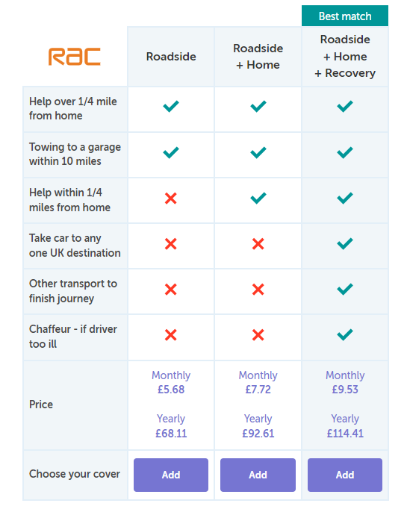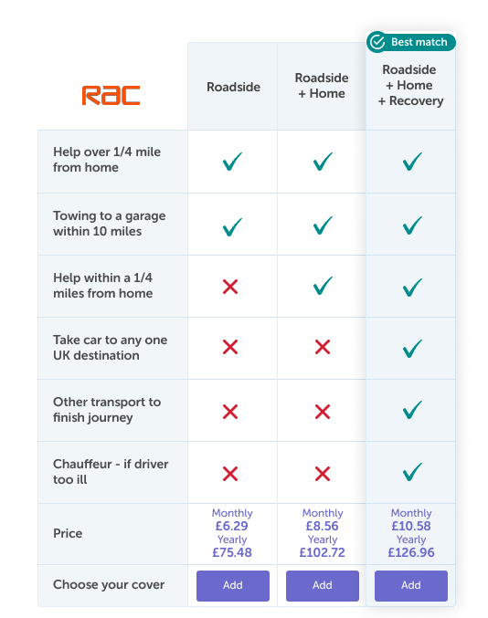Control – Desktop Variation – Desktop

Design changes

**(flow 4,5,6)**

<https://www.figma.com/proto/56UlBMmeMxz7Ffs3nMsGpd/%5BOct%2FNov-QA%5D---Esure-(SW)%3A-Breakdown-Best-Match-Prominence%3A-All-Devices?page-id=0%3A1&node-id=122%3A2796&viewport=241%2C48%2C0.13&scaling=min-zoom&starting-point-node-id=122%3A2796&show-proto-sidebar=1>

Link to Designs

**Variation 4:**

<https://www.figma.com/file/56UlBMmeMxz7Ffs3nMsGpd/%5BOct%2FNov-QA%5D---Esure-(SW)%3A-Breakdown-Best-Match-Prominence%3A-All-Devices>

**Metrics**

|  |  |
| --- | --- |
| **Name** | **Description** |
| Sales: Breakdown | Existing metric |
| BK3 Sales | Existing metric |
| BK5 Sales | Existing metric |
| BK1 Sales | Existing metric |
| Yes clicks on Do you need breakdown cover (primary metric) | New custom metric. Fires if a user sees the error message below the table “Please add a breakdown product above or select I don’t need breakdown cover” |
| Total Add clicks | New custom metric. Number of total “add” clicks in the table |
| I don’t need breakdown clicks | New custom metric. Users clicking “I don’t need breakdown” CTA clicks |
| Add Roadside assist Table CTA click | New custom metric. Users clicking “Add” on Lower tier Roadside assistance CTA |
| Add Roadside and Home Table CTA click | New custom metric. Users clicking “Add” on Lower tier Roadside and Home CTA |
| Add Roadside, Home and Recovery Table CTA click | New custom metric. Users clicking “Add” on top tier Roadside, Home and Recovery CTA |
| Clicks Next Breakdown page | New custom metric: Clicks on next on breakdown page |
| Home Rescue page view | Users viewing Home rescue question. Use  "MOTOR Breakdown Cover - home rescue" pagename from Datalayer |
| Onward Travel Page view | Users viewing onward travel question page. Use "MOTOR Breakdown Cover - onward travel" pagename from Datalayer |
| Breakdown table selection page view | Users viewing onward travel question page. Use "MOTOR Breakdown Cover - selection" pagename from Datalayer |
| Visit page: Final Check | Existing metric |
| Visit page: Payment page | Existing metric |
| Visit page: Find bank | Existing metric |

**Segments**

|  |  |
| --- | --- |
| **Name** | **Values description** |
| Aggregator | “agg” or “not_agg” depending on whether or not the user comes via an aggregator |
| Time of day | “morning”, “evening” or “afternoon” depending on what time of day the user comes to the funnel |

**Integrations**

|  |  |
| --- | --- |
| **Name** | **Values description** |
| Adobe Analytics | eVar138 |

**QA Tier completed by esure**

QA Tier 1 to be carried out by esure (see tier overview below)

What Devices / Browsers have passed QA?

e.g: Safari desktop

**QA Tier to be carried out by REO**

Tier Number 1

(Only QA additional devices / browsers not covered in esure QA)

Please note specific devices/browsers in QA tier to be validated in QA:

e.g iphone 5

**QA Tiers for reference**

